Installation of Maven on Windows

1. JDK and JAVA_HOME:
Make sure JDK is installed, and “JAVA_HOME” variable is added as Windows environment
variable.

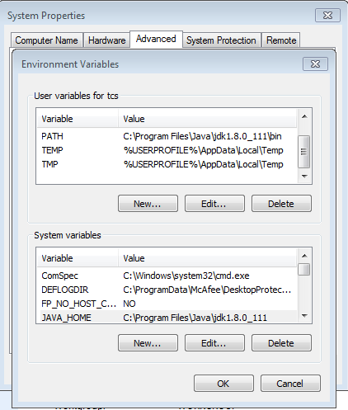

2. Download Apache Maven:
Visit Maven official website, download the Maven zip file, forexample : apache-
maven-3.3.9-bin.zip. Unzip it to the folder you want to install Maven.
Assume you unzip to this folder –
D:\jenkins\apache-maven-3.3.9-bin\apache-maven-3.3.9

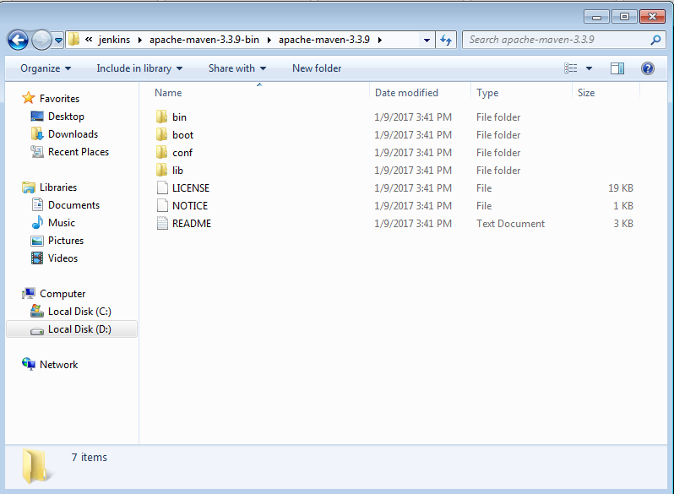

3. Add M2_HOME and MAVEN_HOME:

Add both M2_HOME and MAVEN_HOME variables in the Windows
environment variables.

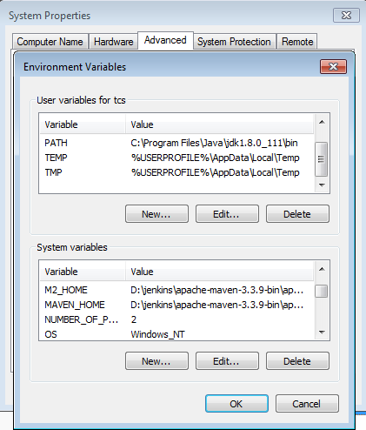

4. Add To PATH:

Update PATH variable, append Maven bin folder – %M2_HOME%\bin, so
that you can run the Maven’s command everywhere.
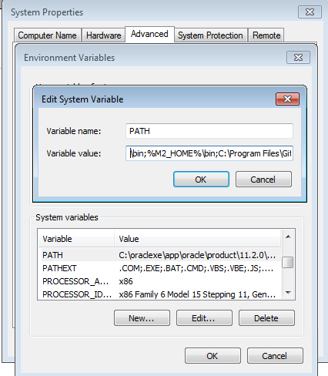



5. Verification:
Done, to verify it, run mvn –version in the command prompt.

